**Principles of Big Data Management – Phase 2**

***Details of Extracted Data*Size**: 2.11 GB  
**Tweets count**: 303,850K Tweets

**Tweets Dataset:** <https://drive.google.com/open?id=1hHjVKE9fkUYs9DYlv6wqt8fWIukRSPwr>

***GitHub Link****:*

***Team Members***

1. Avinash Ganguri – 16293133
2. Sri Sai Nikhil Kantipudi – 16292907
3. Roshna Toke – 16293711

***Queries***

**

**Query 2:**

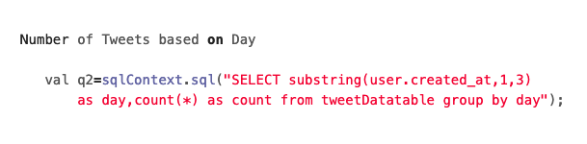

**Query 3:**

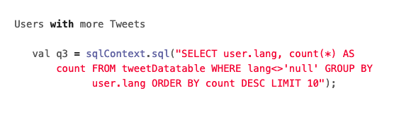

**Query 4:**

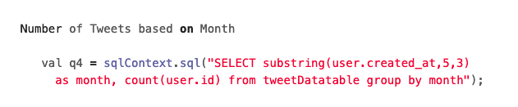

**Query 5:**

**Query 6:**

**Query 7:**

**Query 8:**

**Query 9:**

**Query 10:**

**Query 11:**

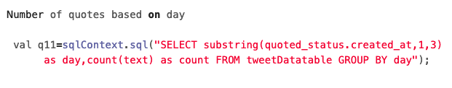

**Query 12:**

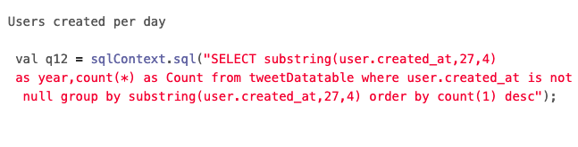

**Query 13:**

